Professional Development Seminar: Technical Writing and Presentation
Speakers: Anant Kukreti
Date: Wednesday, June 22, 2016
Time: 10:00 – 11:30 AM
Venue: University of Cincinnati, Swift Hall, room 516

Prepared by:
Amy Parker, Finneytown High School, Cincinnati, Ohio
RET Participant for Project #1: “Application of Nanocomposites on Controlling Biofilms in Drinking Water Distribution System”

This session on technical writing and presentation was given by Dr. Anant R. Kukreti, Professor in the Department of Biomedical, Chemical and Environmental Engineering and Director for Engineering Outreach for the College of Engineering and Applied Science, on Wednesday, June 22, 2016 from 10:00-11:30 AM at the University of Cincinnati in Swift Hall, room 516. Before coming to the University of Cincinnati in August, 2000 as Head of the Department of Civil and Environmental Engineering (CEE), he spent 22 years at the University of Oklahoma. He then served until 2009 as the Associate Dean for Engineering Education and Research in the College of Engineering and Applied Science. Dr. Kukreti has received multiple awards and has managed multiple grants. Grant management that he has lead or assisted with includes a $9 Million Math and Science Partnership grant, the Ohio Board of Reagents $4.3 Million Choose Ohio First Scholarship grant, a $300,000 REU grant, a $500,000 RET grant, a $600,000 S-STEM grant, and a $2 Million STEP grant. Some of the awards he has received include five major university teaching awards, two Professorships, two national American Society of Engineering Education teaching awards, and international recognition in his primary research field. The topic of this seminar was Technical Writing and Presentation, with a special focus on its application in relation to research reports.

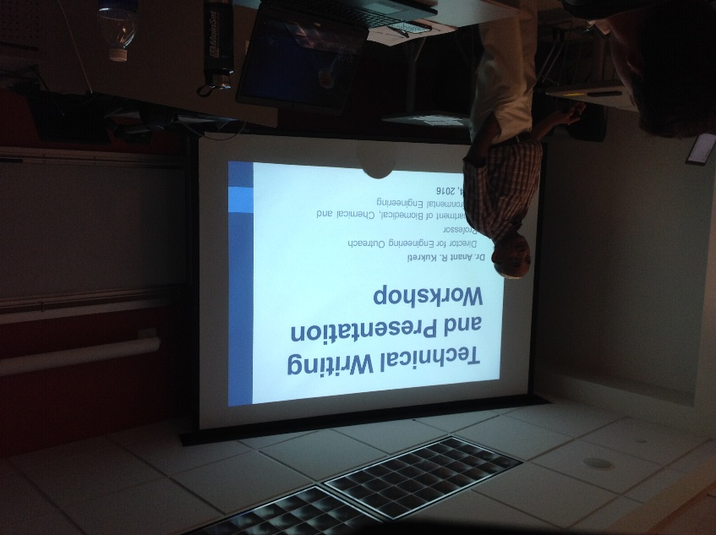

Figure 1: Dr. Kukreti Describing Technical Writing.
In his presentation, Dr. Kukreti described in vivid detail two types of technical reports / presentations to be submitted to the National Science Foundation at the completion of the Research Experience for Teachers (RET) program. These two items are the RET Research Report (or Technical Paper) and the NSF Summary Report. Beginning with the Research Report, Dr. Kukreti went over the general outline of the report. He explained briefly what should be located in each section of the report, then briefly explained the specific formatting requirements for the report’s cover page. Dr. Kukreti stressed the importance of getting the report reviewed by the project’s Research Mentor, approved, and signed on the front cover. Once this is complete, the signed front cover must be scanned back into a digital file and added to the report.
Dr. Kukreti then began to discuss the general formatting guidelines for the main body of the technical report. From the specific text size to number of spaces following a period or semicolon, he included every possible formatting detail that the teachers may encounter as they prepare their reports. Some of the sentence-level tips that he mentioned include the use of active voice, excessive use of unnecessary words, use of jargon and abbreviations, proper use of verbs, and avoidance of personal pronouns. When discussing passive-voice versus active-voice, he included humor to really hone his message home. Through quotations from a recent, popular film, he really captured the attention of the audience.

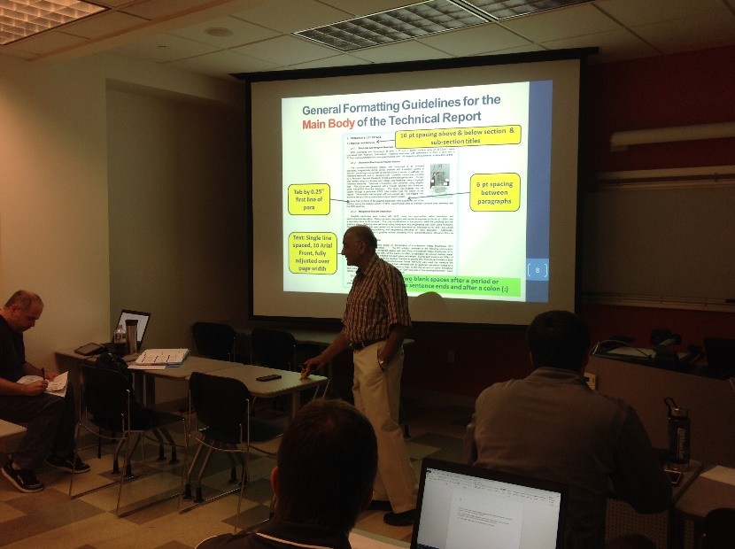

Figure 2: Dr. Kukreti Explaining Technical Writing Presentation

At the conclusion of this workshop, the teachers had a greater understanding of the requirements and expectations for both the RET Research Report and the NFS Summary Report. Supplemental handouts were also distributed with visual references of the material covered in the workshop for later reference.

